**How to Grow Beans: The Ultimate Guide**

**Last updated May 27, 2022**

**Quick Navigation**[[**show**](https://www.epicgardening.com/how-to-grow-beans/)]

Beans are one of the most powerful and versatile plants you can plant in your garden. They yield a massive amount of pods, and are nitrogen-fixers, meaning they add valuable nitrogen back to your soil. Learning how to grow beans can not only give you tons of produce, but it can be good for your soil!

No matter how they’re eaten – shelled, whole, dried, or fresh – beans are one of the most popular veggies in the garden for many reasons.

They grow easily and there are enough varieties that you can find one to fit just about any climate or growing condition combination that is out there. And best of all, they taste good!

Let’s start out with a short video on growing bush beans in a vertical tower system, then go into the wide and varied world of all beans.

**[](https://shop.epicgardening.com/)**

By the time we’ve finished, you’ll know how to [**grow pole beans**](https://www.epicgardening.com/pole-beans/) or bush beans for shelling or fresh-eating! And you’ll always be able to provide a steady supply of this delicious staple vegetable for your fridge or pantry.

**Facts about Beans :**

|  |  |
| --- | --- |
| **Common Name** | Beans |
| **Scientific Name** | Phaseolus vulgaris |
| **Germination Time** | 7-14 days depending on cultivar |
| **Days to Harvest** | 50-100 days depending on cultivar and type |
| **Light** | Full sun |
| **Water** | Moist, even watering (1” or less per week) |
| **Temperature** | 70-85 degrees Fahrenheit is optimal |
| **Humidity** | Tolerant but can develop fungal issues |
| **Soil** | Sandy or silty loam, well-draining |
| **Fertilizer** | Compost, or alternately a 5-10-10 slow-release fertilizer as needed. |
| **Pests** | Mexican bean beetles, spider mites, aphids, thrips, cucumber beetles, Japanese beetles, cutworms, leafhoppers, woodchucks. |
| **Diseases** | Susceptible to sclerotina (white mold), bacterial blights, anthracnose, bean rust, downy mildew, and the bean mosaic virus. |

### When To Plant Beans

You can start planting beans from seed a week or two prior to the date of the last expected frost.

For bush beans, continue planting them about every two weeks throughout the growing season to ensure constant production. These plants will die back quicker than pole beans will.

Most pole and runner bean varieties will produce all season long from their vines. For these, you can sow once early in the season, and then if you’d like, start a second batch a month or two later. That will give you an abundance of beans come harvest time. Be sure to harvest regularly to encourage more beans to form.

**Epic Gardening is reader-supported. When you buy through links on our site, we may earn an affiliate commission.**[**Learn more**](https://www.epicgardening.com/disclaimer/)

[Home](https://www.epicgardening.com/) » **How to Grow Beans: The Ultimate Guide**

# How to Grow Beans: The Ultimate Guide

**Last updated May 27, 2022**

**Quick Navigation**[[**show**](https://www.epicgardening.com/how-to-grow-beans/)]

Beans are one of the most powerful and versatile plants you can plant in your garden. They yield a massive amount of pods, and are nitrogen-fixers, meaning they add valuable nitrogen back to your soil. Learning how to grow beans can not only give you tons of produce, but it can be good for your soil!

No matter how they’re eaten – shelled, whole, dried, or fresh – beans are one of the most popular veggies in the garden for many reasons.

They grow easily and there are enough varieties that you can find one to fit just about any climate or growing condition combination that is out there. And best of all, they taste good!

Let’s start out with a short video on growing bush beans in a vertical tower system, then go into the wide and varied world of all beans.

**[](https://shop.epicgardening.com/)**

By the time we’ve finished, you’ll know how to [**grow pole beans**](https://www.epicgardening.com/pole-beans/) or bush beans for shelling or fresh-eating! And you’ll always be able to provide a steady supply of this delicious staple vegetable for your fridge or pantry.

## Beans: Quick Care Guide

|  |  |
| --- | --- |
| **Common Name** | Beans |
| **Scientific Name** | Phaseolus vulgaris |
| **Germination Time** | 7-14 days depending on cultivar |
| **Days to Harvest** | 50-100 days depending on cultivar and type |
| **Light** | Full sun |
| **Water** | Moist, even watering (1” or less per week) |
| **Temperature** | 70-85 degrees Fahrenheit is optimal |
| **Humidity** | Tolerant but can develop fungal issues |
| **Soil** | Sandy or silty loam, well-draining |
| **Fertilizer** | Compost, or alternately a 5-10-10 slow-release fertilizer as needed. |
| **Pests** | Mexican bean beetles, spider mites, aphids, thrips, cucumber beetles, Japanese beetles, cutworms, leafhoppers, woodchucks. |
| **Diseases** | Susceptible to sclerotina (white mold), bacterial blights, anthracnose, bean rust, downy mildew, and the bean mosaic virus. |

## Recommended Bean Varieties

Shopping for bean seeds can be a bit complex because there’s a lot of terms that are thrown around. Bush or pole? Shelling or runner? Let’s go over some of these types of beans to understand them a bit more.

### Shelling Beans

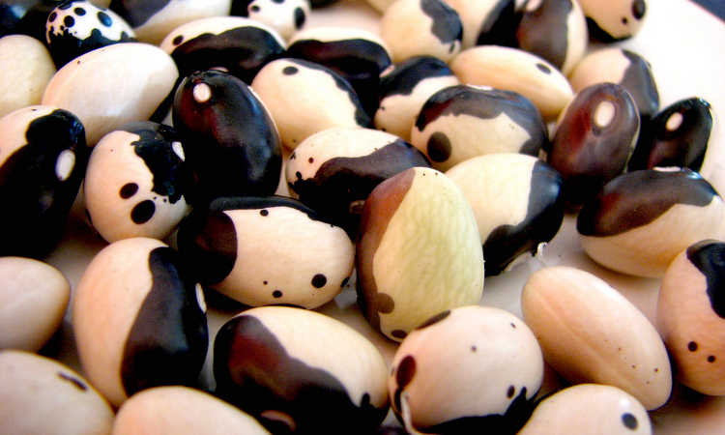[**Yin Yang shelling beans. Source: artescienza**](https://www.flickr.com/photos/curiosita/2786921589/)

Shelling beans are typically beans meant to be eaten out of their pod, whether dried for storage or fresh. Some popular varieties of shelling beans include pinto or black beans, kidney beans, and the like. While some types of shelling beans can be eaten in their green young stage as green beans, most are grown for their distinctive seeds.

|  |  |  |  |
| --- | --- | --- | --- |
| **Variety** | **Growing Time** | **Description** | **Where To Buy** |
| Dainagon | 90 days | Adzuki shelling bean from Japan, late maturing variety with large seeds. Bush type. | [**Buy Seeds**](http://www.kitazawaseed.com/seed_501-2.html) |
| Yin Yang | 75 days | Striking black and white beans with a flavor similar to turtle beans. Bushing habit. | [**Buy Seeds**](http://www.territorialseed.com/product/Yin_Yang_Bean_Seed) |
| Ojo De Tigre | 75 days | Sometimes called Tiger’s Eye. Shelling bean that can also be eaten young as a snap bean. Brilliant yellow seed. | [**Buy Seeds**](https://www.rareseeds.com/ojo-de-tigre-bean/) |

### Pole & Runner Beans

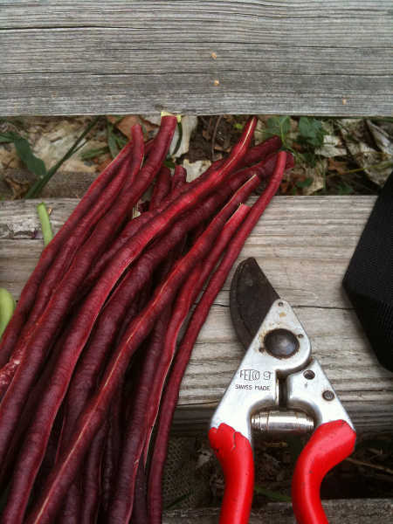[**Red Noodle beans alongside a set of Felco pruners. Source: karenchristine552**](https://www.flickr.com/photos/karenchristinehibbard/4889821580/)

Pole and runner beans are climbing bean varieties usually grown as a snap bean. These can also be dried for storage, but they tend to be more popular as an edible-pod bean. Runner beans can be particularly pretty due to their distinctive flowers. Pole varieties also often include the “yard long” bean types with extremely long pods.

One note about the runner bean varieties: these typically like cooler weather than most pole beans. If you live in an area which has a shorter growing season or cooler temperatures, these may be great performers for you. Those of us who live in more desert-like climates may have a more difficult time of growing runner beans than pole beans.

|  |  |  |  |
| --- | --- | --- | --- |
| **Variety** | **Growing Time** | **Description** | **Where To Buy** |
| Red Noodle | 85 days | High-yielding burgundy-colored beans with pod lengths of up to 20″. Color fades when cooked. | [**Buy Seeds**](http://www.johnnyseeds.com/vegetables/beans/pole-beans/red-noodle-bean-seed-2626.html) |
| Scarlet Runner | 80 days | Roughly 8″ long bean pods on a climbing plant with beautiful red flowers. | [**Buy Seeds**](http://www.burpee.com/vegetables/beans/bean-scarlet-runner-pole-prod000599.html) |
| Kentucky Wonder | 72 days | Nice long green bean pods on a vigorous plant. One of my favorite green beans. | [**Buy Seeds**](https://sustainableseedco.com/collections/bean-seed/products/kentucky-wonder-pole-bean) |

### Bush Beans

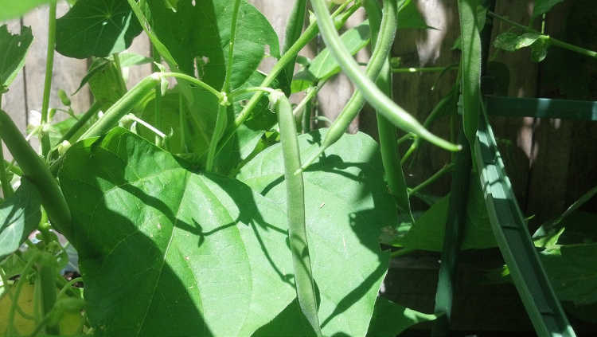[**Blue Lake 274 bush beans. Source: dreamexplorer**](https://www.flickr.com/photos/dreamexplorer/7432766604/)

[**Bush beans**](https://shop.epicgardening.com/collections/seeds-1/products/organic-golden-wax-bush-bean-seeds)don’t climb like pole beans or runner beans do. These tend to stay in a compact, bushy mass, rarely growing over 3′ tall. They also tend to produce for shorter periods of time than the vining varieties do. However, bush beans are great for people who don’t have space for trellising and can be vigorous producers during their shorter seasons.

|  |  |  |  |
| --- | --- | --- | --- |
| **Variety** | **Growing Time** | **Description** | **Where To Buy** |
| Dragon’s Tongue | 57 days | Pale yellow snap bean pods with purple streaking, very unusual. Purple fades when cooked. | [**Buy Seeds**](http://www.johnnyseeds.com/vegetables/beans/bush-beans/dragons-tongue-bean-seed-3175.html) |
| Royalty Purple Pod | 60 days | Bright purple pods which form on compact plants. Snap bean pods turn green during cooking. | [**Buy Seeds**](http://www.burpee.com/vegetables/beans/bean-bush-royalty-purple-pod-organic-prod002228.html) |
| Provider | 50 days | Nice snap bean variety with maroon-colored seeds inside. Sturdy bush structure. | [**Buy Seeds**](https://sustainableseedco.com/collections/bean-seed/products/provider-bush-bean-seeds) |

### Unusual Beans

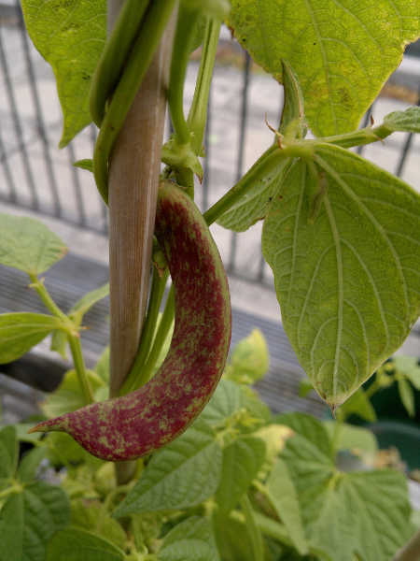[**Borlotto di Vigevano Nano beans. Source: themediatedgarden**](https://www.flickr.com/photos/themediatedgarden/5981292598/)

Edamame beans, fava beans, and lima beans fall into this category, as do a few lesser-known varieties. Some are definitely shelling varieties (such as edamame or fava), where others are just wildly colored and rarely seen in a commercial market setting.

|  |  |  |  |
| --- | --- | --- | --- |
| **Variety** | **Growing Time** | **Description** | **Where To Buy** |
| Borlotto Di Vigevano Nano | 60 days | The seeds are pink and white in tone and make great shell beans. The red-splashed cream or yellow pods can also be eaten as a snap bean. | [**Buy Seeds**](https://www.rareseeds.com/borlotto-di-vigevano-nano-b/) |
| Mappe Green | 70 days | Mung beans like Mappe are most popular for bean sprouts in 7-10 days, but can also be cultivated for green beans. | [**Buy Seeds**](http://www.kitazawaseed.com/seed_169-6.html) |
| Vroma | 75 days | This fava bean variety produces large pods, each with 4-5 big seeds. Cook like a shelling bean. | [**Buy Seeds**](http://www.johnnyseeds.com/vegetables/beans/fava-beans/vroma-bean-seed-3171.html) |

## Planting Beans

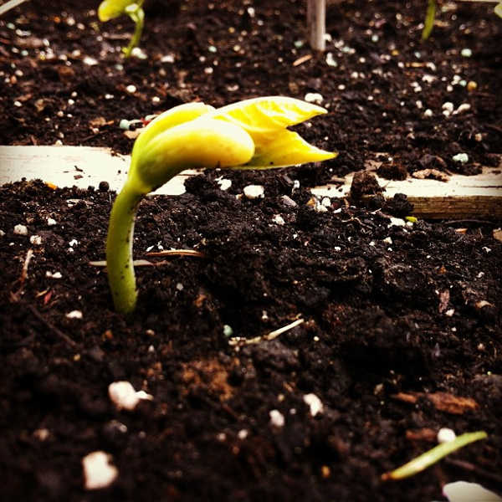[**Bush bean sprout. Source: xinem**](https://www.flickr.com/photos/christinestephens/8732712476/)

Even though there’s a huge selection of beans from which to choose, they all tend to grow in a similar fashion. Let’s go over the basics!

### When To Plant Beans

You can start planting beans from seed a week or two prior to the date of the last expected frost.

For bush beans, continue planting them about every two weeks throughout the growing season to ensure constant production. These plants will die back quicker than pole beans will.

Most pole and runner bean varieties will produce all season long from their vines. For these, you can sow once early in the season, and then if you’d like, start a second batch a month or two later. That will give you an abundance of beans come harvest time. Be sure to harvest regularly to encourage more beans to form.

### Where To Plant Beans

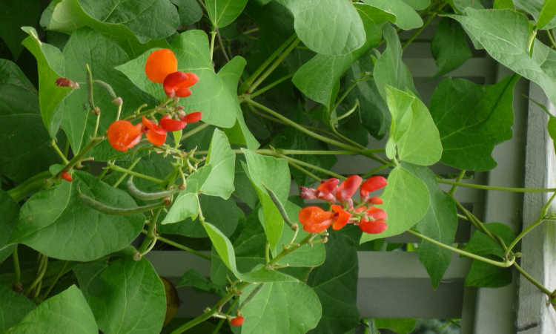[**Scarlet Runner bean vines. Source: eXtension.org**](https://www.flickr.com/photos/extensionhorticulture/2862495109/)

Full sun is ideal for beans, and so it’s important to plant them where they’ll get lots of light.

Bush varieties are lower to the ground, so should be in a location where they won’t accidentally be shaded by other plants. Pole beans will climb up above the height of most other plant types, so they need to be somewhere where a trellis or support system can be located.

You can grow beans in raised beds or directly in the soil, along fencelines in garden beds, or virtually anywhere else, as long as they have full sun and moist soil.

### How To Plant Beans

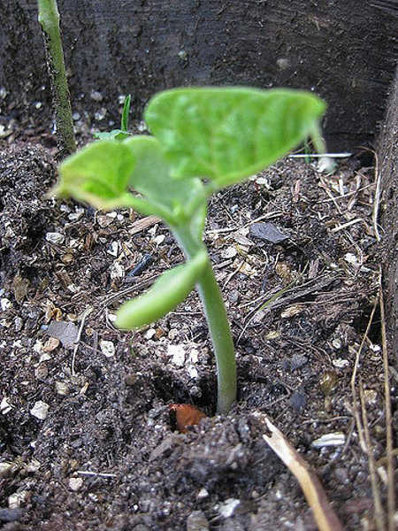[**A young Kentucky Wonder bean plant. Source: Kari Kilgore**](https://www.flickr.com/photos/realvirginiahighlands/3849590793/)

For most varieties of bush bean, plant 2″ apart and 1.5″ deep in rows for best growth. Doing that will give you a nice, dense mat of bean plants as they mature. Plant another set every two weeks to continue getting regular harvests throughout the summer and fall months.

Plant pole beans in single rows 3 to 4 feet apart or double rows spaced 1 foot apart. Sow seeds 2 inches deep and 8-10 inches apart. Pole beans will vine out significantly as they grow, so can be spaced much further apart than bush beans can.

Alternately, you can start your pole beans ahead of time and then plant out transplants when your plants are 6-8″ tall. However, it’s generally easiest to just direct-sow and let the beans grow on their own.

You can plant multiple varieties near each other if you are not planning on collecting seed. However, if you’re going to harvest seed to plant the following year, keep different cultivars separated so they don’t cross-pollinate.

### Fertilizing

Beans are considered to be a nitrogen-fixing plant, and in fact aren’t very heavy feeders. For best production, you can work a compost that’s rich in organic matter through your soil, and that should provide most of the nutrition your plants need. If you feel the need to supplement, opt for a 5-10-10 slow-release fertilizer. Avoid excess nitrogen as it will convince your plants to produce more vines or leaves and less flowers and seed pods.

### Harvesting Beans

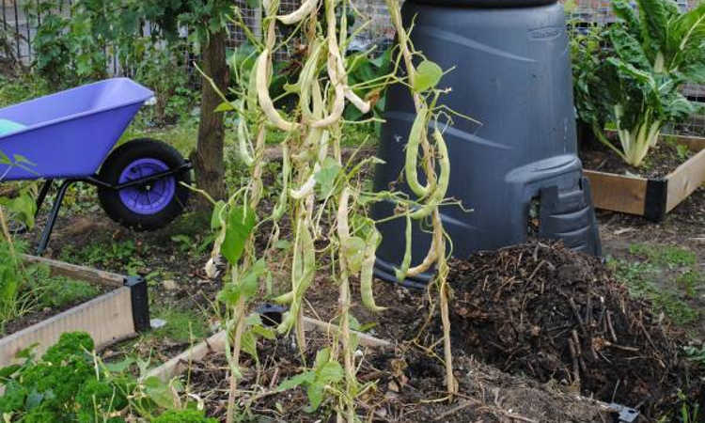[**Kidney beans drying on the vine. Source: Garden Club2011**](https://www.flickr.com/photos/miss-cullen-james/6126136833/)

When green beans have reached the estimated pod size for their variety, harvest them by snapping them off the vine. Do not pull them off, as that risks damage to the vine. They should be firm enough to easily snap through.

If you are growing beans to be shelled and wish to use them when fresh, you can harvest them just as you would green beans once the seeds inside have reached full size. Again, don’t tug on the vine or bush to prevent plant damage.

Finally, if you plan on drying your beans, most bean varieties can simply be left to dry on the plant. When the pod has dried out completely, the beans will rattle around inside and the pod should be crunchy and paper-thin. Harvest when 90% or more of the leaves of the plant have gone brown and dry.

If weather conditions are going to prevent your beans from drying in the garden, you can pull up your plants and hang them indoors, plant and all, to finish drying out the pods.

### Other Ways To Preserve Fresh Whole Beans

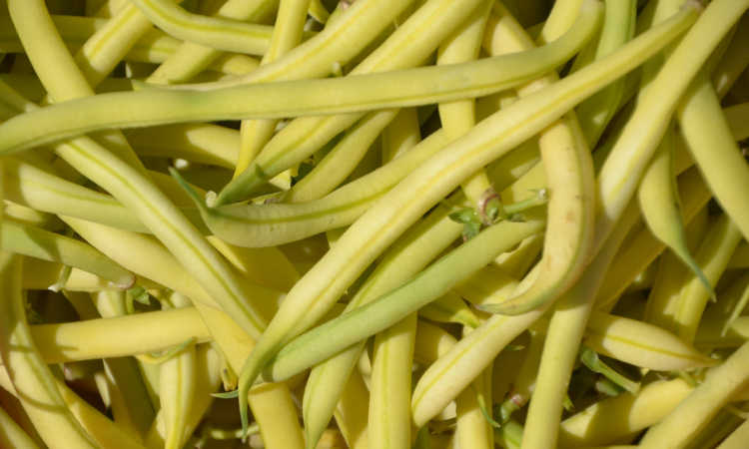[**Yellow wax beans. Source: Suzies Farm**](https://www.flickr.com/photos/suziesfarm/7971322898/)

### Pests

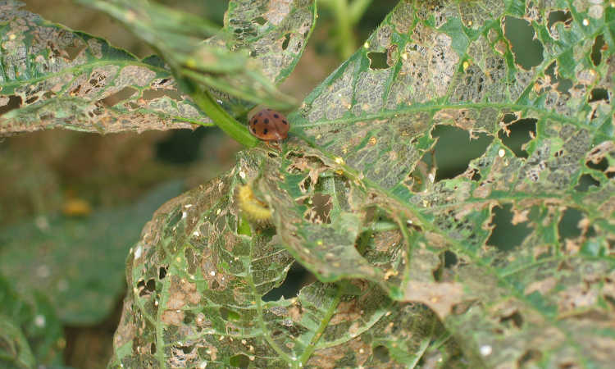[**Mexican bean beetles can skeletonize leaves quickly. Source: Jason Riedy**](https://www.flickr.com/photos/jason-riedy/2787059272/)

There’s a wide variety of pests which will happily attack your beans, but the worst is the [**Mexican bean beetle**](https://www.epicgardening.com/mexican-bean-beetle/). These beetles will rapidly skeletonize the leaves of your plants and scar your beans. Hand-pick them off your plants, and keep them from sticking around by spraying your plant with an azadirachtin spray like **[Azatrol EC](https://amzn.to/2wRVKqP)**.

[**Spider mites**](https://www.epicgardening.com/spider-mites/),  [**aphids**](https://www.epicgardening.com/aphids/) and [**thrips**](https://www.epicgardening.com/thrips/) can suck the sap out of bean leaves, causing them to yellow, curl inward, or distort. To combat these tiny little garden pests, spray all surfaces of your bean plants with [**neem oil**](https://amzn.to/2qaCulJ).

Adult [**cucumber beetles**](https://www.epicgardening.com/cucumber-beetle/) will nibble holes in the leaves of your plants while the larval stages will attack the roots. Using a pyrethrin spray such as [**Safer Brand Yard & Garden Spray**](https://amzn.to/2wGYt9N) will help wipe these pests out.

[**Japanese beetles**](https://www.epicgardening.com/how-to-get-rid-of-japanese-beetles/) will also happily chew bean leaves into little tatters. Repel these pests with a thorough spraying of [**neem oil**](https://amzn.to/2qaCulJ).

The [**cutworm**](https://www.epicgardening.com/cutworms/) will literally make young bean plants collapse at the base, chewed cleanly through. Use a bacillus thurigiensis spray like [**Monterey BT**](https://amzn.to/2g3f6Xg) to kill off these little caterpillars.

[**Leafhoppers**](https://www.epicgardening.com/leafhopper/), too, may find your plants to be appetizing targets. With the aid of a product like [**Bon-Neem**](https://amzn.to/2zykaaA), you can clear these pests out of your garden.

Finally, a surprising non-insect pest that most don’t consider is the woodchuck. While it’s not something tiny and rapidly-breeding, that doesn’t make it any less dangerous! Woodchucks will devour your crops if left unchecked. You can sprinkle a blend of blood meal and ground black pepper around your garden to deter these pests, or use a predator urine spray to keep them at bay. If those options don’t work, you may have to resort to traps and contacting animal control to haul them off.